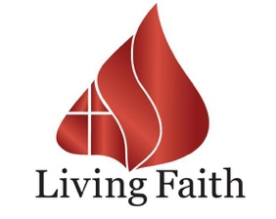

2025 Your Year of Supernatural Help!

Is 58:6 “Is this not this the fast that I have chosen? To lose the bands of wickedness, to undo the heavy burdens, and to let the oppressed go free, and that ye break every yoke?”

- 21 Days of Prayer and Fasting is not a hunger strike. It is a position we as a church take to inform every natural thing, that our spirit is in charge, and not the flesh.

- It is also a time set apart where our spirit will take new heights in the things of God.

- We do not do it to persuade God. He has already blessed us. We fast to condition our spirit to receive from God, what rightfully belongs to us.

- We fast to partner with God, so we can be a clean vessel in His hands.

Ps 24:3-4 “Who shall ascend into the hill of the Lord? Or who shall stand in his holy place? “He that hath clean hands, and a pure heart; who hath not lifted up his soul unto vanity, nor sworn deceitfully.”

Prov 20:27 “The spirit of man is the candle of the Lord, searching all the inward parts of the belly.”

Nothing changes in the spirit until we pray. Nothing can be preserved unless we pray. Preservation and change only take place in prayer.

I want to encourage all of you to come out to pray and be a part of what the Lord is doing in our churches, because we are going to another realm.

